Topics in Smart Grid

# 1. Smart Grid

The term grid refers to an electricity system that supports the following operations: electricity generation, electricity transmission, electricity distribution, and electricity control. The conventional grid transmits power from central power generators to a large number of customers. In contrast, the smart grid implements a two-way flow of electricity and information between electricity companies and customers. The smart grid can be considered as a modern electric power grid infrastructure for enhanced efficiency and reliability through automated control, high-power converters, modern communications infrastructure, sensing and metering technologies, and modern energy management techniques based on the optimization of demand, energy and network availability, and so on [1]. Table 1 below spots some differences between the conventional grid and the smart grid.

|  |  |
| --- | --- |
| **Conventional Grid** | **Smart Grid** |
| Electromechanical | Digital |
| One-way communication | Two-way communication |
| Centralized generation | Distributed generation |
| Few sensors | Sensors throughout |
| Manual monitoring | Self-monitoring |
| Manual restoration | Self-healing |
| Failures and blackouts | Adaptive and islanding |
| Limited control | Pervasive control |
| Few customer choices | Many customer choices |

Table 1:- A brief comparison between the Conventional Grid and the Smart Grid [2]

With the help of modern information technologies, the Smart Grid has the potential of responding to events occurring in the grid, such as generation of power, transmission, distribution, and consumption, and adopt new strategies as needed. An example can be seen in demand profile shaping; reducing the demand during peak time reduces the plant and capital cost requirements. In peak period the power companies could use real-time pricing to tell customers to reduce their electricity consumption, which in turn affects the demand profile nicely. From a technical perspective, the smart grid can be divided into three major systems [2]:-

* Smart infrastructure system: This is the energy, information, and communication infrastructure that supports advanced electricity generation, delivery and consumption; advanced information metering, monitoring, and management; and advanced communication technologies.
* Smart management system: This is a subsystem of Smart Grid that supplies advanced management and control services.
* Smart protection system: This is a subsystem that supplies advanced grid reliability analysis, failure protection, and security/privacy protection services. The smart grid also aims to provide a protection system which can be more efficient in helping failure protection mechanisms, addressing cyber security concerns, and ensuring privacy.

The smart grid is anticipated to fulfil these benefits and requirements [2]:-

1. To improve power reliability and quality.
2. Advancing facility utilization and preventing the need for back-up power plants.
3. Improving the efficiency of current electrical power networks.
4. Improving resilience to disruption.
5. Facilitating predictive support and self-healing measures to system commotions.
6. Aiding expanded distribution of renewable energy sources.
7. Allowing distributed power sources.
8. Making maintenance and operations automated.
9. Eradicating greenhouse gases emissions by promoting electric vehicles and new power sources.
10. Decreasing oil consumption by eradicating the need for wasteful generation during peak periods.
11. Introducing new opportunities for improving grid security.
12. Facilitating new products, services, and markets.
13. Facilitating the transition to plug-in electric cars and new options for storing energy.
14. Increasing consumer’s choice.

# 2. Open Automated Demand Response (OpenADR)

We electricity consumers do not normally pay attention to when we use energy and we all tend to use energy at the same time e.g. when we get back from work, Saturdays when we do our laundry/cleaning. On days when the demand for energy becomes high, extra power plants are used to meet the demand for electricity, these power plants may be more expensive to operate however. The challenge is to meet the demand for electricity without having to implore extra power plants. Instead of imploring extra power plants, electricity consumers could reduce their electricity consumption at peak demand periods or use electricity at a later time.

Demand Response (DR) can be defined as a service utilized by utility companies or Independent System Operators (ISOs) that informs electricity consumers to reduce their electricity usage temporarily, in order to avoid high electricity charges due to high demand for energy. The aim is to avoid the demand for electricity to exceed the supply available, this prevents cases of power outages and total black outs. Demand Response could be done manually, fully automated, or semi-automated. Demand Response was normally done manually by calling, texting or emailing clients and electricity consumers, this approach wasn’t efficient however [3]. The increasing demand for electricity and the peak electricity prices led to the invention of OpenADR [4][5].

## 2.1 Overview of OpenADR

Open Automated Demand Response (OpenADR) provides a non-proprietary, open, standardized and secure demand response (DR) interface that allows electricity providers to communicate DR signals directly to existing customers using a common language and existing communications such as the Internet [6]. OpenADR is a data model for communicating events (DR signals, price schedules, grid stability) between a DR server also known as Virtual Top Node (VTN) and DR Clients also known as Virtual End Nodes (VEN) [7]. OpenADR 1.0 was developed in 2002 at the Berkeley Laboratory, the aim was to provide an interface that aids electricity providers to send DR signals to existing customers. OpenADR 2.0 was later developed due to the ever increasing peak demand and electricity costs. In version 2.0, the server component is the VTN, and whereas the client element is the VEN. Devices can be VTNs, VENs, or a combination of both. Sometimes the VEN acts as VTNs for other VENs.

OpenADR 2.0 contains two versions, the 2.0a version is for simple devices (e.g., thermostats), while the 2.0b version is for full-featured energy management solutions (e.g., energy management systems and DR aggregators) [3]. OpenADR 2.0b allows for more options such as pricing, telemetry operations and two way communications, it can communicate market participation information and improve load prediction ability due to its two way communication. Version 2.0b also supports dynamic price signals and emergency signals. OpenADR 2.0 contains a set of data models that assists simple DR programs, dynamic pricing, wholesale market dealings, and distributed resources management via storage and local generation [8][9]. The expansion of the data models in OpenADR 2.0 would lead to wider-scale use for new applications. Some key differences between the two can be seen in the table below.

|  |  |
| --- | --- |
| **OpenADR 1.0** | **OpenADR 2.0** |
| Limited number of vendors. | Large, rapidly growing ecosystem of vendors. |
| No certification program. | Test tool, test plan & certification. |
| Geared towards local DR programs. | Flexible to adjust to most DR programs. |
| Limited feedback capabilities. | Explicit feedback capabilities. |
| Lacks test tool and harness for implementers. | Expanded architecture to include pricing, telemetry and other services. |

Table 2:- Some key differences between OpenADR 1.0 and 2.0 [8][6].

OpenADR 1.0 created a technical framework and validated the concept of automated communication of price and reliability signals from utilities to customers. OpenADR 2.0 is building on this framework to create a standardized testing and certification process to support growing global interest and advanced features [6].

### 2.1.1 Method of Communication

A VEN is usually a gateway that controls one or more devices that could participate in DR, it could also be a module co-located on an end device (e.g., a smart thermostat) with the ability of being directly controlled by OpenADR [3]. A VEN normally controls devices using other protocols as well as OpenADR, this allows the deployment of both OpenADR devices and devices using other protocols as well. OpenADR nodes are normally organized in a tree like hierarchy. A simple example could be when a tree only has one VTN-VEN pair (e.g., one tree hop). In general there can be multiple hops; in such cases intermediate nodes may have both VTN and VEN functionalities as seen in the figure below.

Figure 1:- An Overview of the relationship between the VTN and VEN in OpenADR [7].

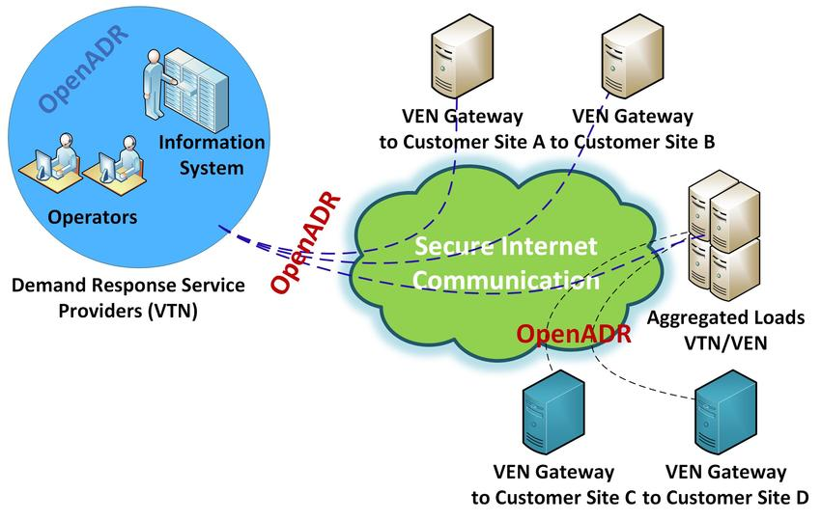

OpenADR supports HTTP and XMPP transport mechanisms. XMPP is best known as an online chat protocol. In HTTP, two methods are used HTTP PULL and HTTP PUSH. The VEN uses HTTP PULL by periodically polling for new messages from the VTN; this enables connections from VENs behind Network Address Translations (NATs) and firewalls. The PULL mode can cause serious communication overhead however, this is due to the periodic polling. The HTTP PUSH method allows the VEN and the VTN to establish communication whenever necessary, this eradicates traffic in the network. However, it requires the VEN to keep listening for new messages on an open port; this is unwise especially when firewalls and NATs are used, because it could cause security concerns. The PUSH mode is implemented on XMPP, because we wouldn’t need to deal with firewalls as XMPP supports client-initiated TCP connections that allows communication behind firewalls and NATs [3][7]. The XMPP transport protocol is appropriate for bidirectional exchanges of messages in OpenADR, this makes it ideal for fast Demand Response and additional services [6].

### 2.1.2 Messages and Services

Message payloads are defined by an XML schema. The services provided by OpenADR 2.0b are namely: Event Service (EiEvent), Report Service (EiReport), Registration Service (EiRegisterParty), Opt Service (EiOpt), Poll Service (OadrPoll). In EiEvent, DR Signals are sent from the VTN to a VEN informing the VEN to reduce the electricity energy consumption of the devices it is attached to. The message normally contains information about, the start time, duration, amount of load curtailment required, current electricity price, and so on. The VEN sends an acceptance or denial to the participation as a response message. Events could have one or more different segments/levels for various prices, curtailment levels, or other signals applicable to the DR program [6].

In EiReport, the VEN normally sends report about electricity consumption or status of connected devices to the VTN. OpenADR also allows for historical reports which includes series of data points that were taken in the past, as well as forecast and telemetry reports which are regularly sent in a certain time frame. The VEN initially sends a METADATA report that includes all of its reporting capabilities (e.g., sampling frequency, measuring unit, amount of buffered data, devices it controls, and so on.); based on the METADATA the VTN can request appropriate reports whenever necessary. The 2.0b profile unfortunately doesn’t not allow for addition or deletion of capabilities in the METADATA; that means when changes in capabilities occur, the VEN have to repeat the registration process and send all reporting capabilities [3].

The EiOpt service is normally utilized by the VEN to inform the VTN about temporary availability schedule, or can be used to qualify the devices that would participate in an event. It helps the demand response program operators and customers to better plan their resources efficiently. The EiRegisterParty service is initiated by the VEN, and is used to exchange information required that will in turn aid interoperable exchange of payloads. The OadrPoll is a service utilized by VENs to poll payloads of any other services from the VTN; it is mostly utilized by simple devices that cannot fully support additional messaging [6].

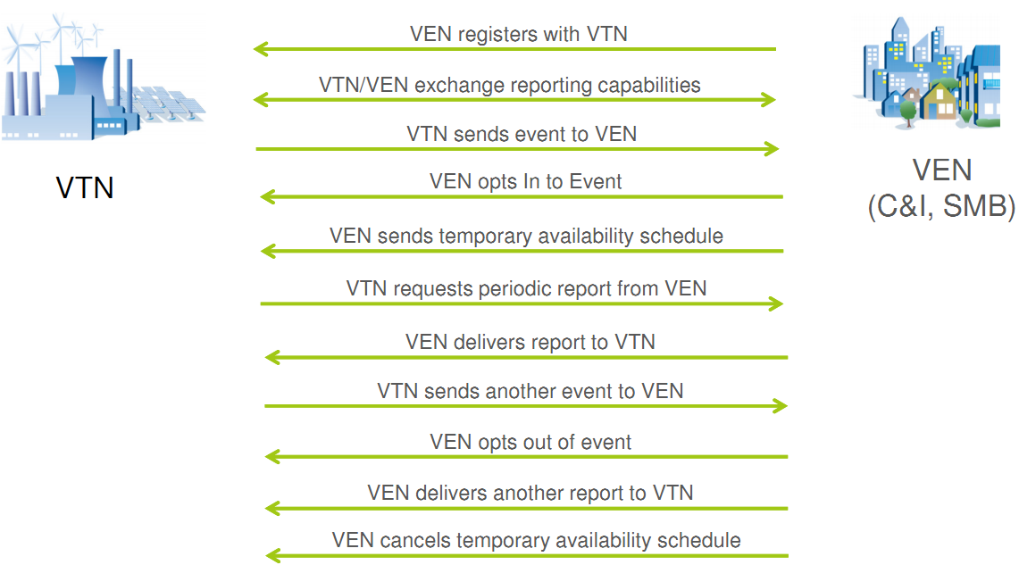

Figure 2:- Shows an example of OpenADR message exchanges between the VEN and the VTN [10].

### 2.1.3 Security

The Transport Layer Security (TLS) protocol with client authentication is utilized on both the server and client side in OpenADR 2.0; this promotes message integrity and security of confidential information. In OpenADR 2.0, all nodes (VTNs and VENs) are to be equipped with public/private key pairs and digital certificates which are given by a reliable Certificate Authority (CA); this means that merchants will have to pay for the issuance and management of the certificates. Authentication is done between the VTNs and VENs via the digital certificates.

During the VENs authentication, an identifier of the VEN (ven_ID) and a particular information is taken from the VEN’s digital certificate (e.g., a SHA fingerprint of the certificate). The VTN performs validation using a one-to-one mapping of the ven_ID and the digital certificate; this helps the VTN to verify an incoming message is coming from the actual VEN whose ven_ID id in the payload [3].

### 2.1.4 Benefits of OpenADR

There are many benefits of using automated demand response, they all come with the OpenADR standard specification, and these benefits can be summarized as follows [7]:

* **Customer Control**: - Utility companies can have full control over building appliances using mechanisms known as Direct Load Control (DLC). In OpenADR, customers have the ability to respond to DR signals by adjusting their power usage, opting in and out of a DR program, discarding a DR signal, and allocating the number of interventions by the utility.
* **Supports Aggregated Curtailment**: - The amount of consumed energy by households is small as compared to commercial/industrial companies. However, if electricity consumers cooperate with one another and reduce their energy usage even by a fraction, it adds up to a much greater value for the community.
* **Diverse Signaling Strategies**: - In OpenADR, there are several mechanisms utilities could use in the shaping of the demand profile (e.g., by giving incentives to shift load to desired time slots), demand profile shaping is a dynamic process. The power companies can provide the demand needs in advance or in real time irrespective of the price structure; they can request for decrease or increase in power consumption; they can target specific loads and appliances of the customer. OpenADR can meet the needs and requirements of the utility companies and the customers as well.
* **Supports Ancillary Services: -** OpenADR can support ancillary services like frequency regulation. This service requires fast response (i.e. 2-4 secs), therefore only real-time signaling can be applied. An example can be seen in vehicle-to-grid concepts where connected battery-powered vehicles can provide frequency regulation when charging or discharging to and from the grid.
* **Supports the integration of renewable energy sources:** - There has been an increase in the use of renewable energy sources in the past years (e.g., solar and wind turbines). The power supplied from these sources is irregular. Automatic operations is the best way to integrate these sources while keeping the grid stable at the same time. OpenADR allows grid operators to be able to integrate these resources at low cost as compared to costly power plants.

## 2.2 OpenADR in the context of Smart Grid

One of the visions of the smart grid is to enable facilities (residential, commercial, industrial) to dynamically respond to the electricity supply. Demand Response (DR) is becoming an essential part of the grid planning and operation. As the power demand approaches the existing supply capacity, automated demand response becomes more important for balancing energy demand and supply. Facilities can function in a way that promotes grid reliability by adjusting power consumption to eradicate peak demands on the electric grid.



Figure 1:- Illustrates the system load “shaping” behavior measured in a building [11].

OpenADR could be the key standard to move the smart grid forward internationally. The feature that makes OpenADR distinct from other DR programs is that the DR requests doesn’t contain any information about the specific devices or operations that should be reduced or stopped. OpenADR sends only the utility’s request for demand reduction to a client/customer; it could be either by direct request or through the distribution of increased energy cost rate schedules, which can serve as a motivation to the customer to reduce his/her utility demand.

An example could be seen in a case whereby, utilities must reduce load to maintain grid stability. One or more customers could participate in a DR program and agree to respond to utility requests by shedding load over a given time period. A DR event is sent to participating customers requesting they shed some load, a verification is sent back that the request has been received. If a client fails to respond to the DR event, this will result in penalties when the utility rate charges are calculated. A client can decide not to participate in a DR program by opting out over a certain time interval [11]. Another example could be seen in a case where power companies modify energy costs, in order to motivate clients to reduce demand. The OpenADR server could send “price events” showing elevated costs over a certain time period, clients could then be motivated to reduce utility demand in order to avoid higher power charges.

OpenADR is one of the most common standards used by power companies for demand response automation. It’s advancing in commercial adoption in United States, Canada and Globally. The major benefits of OpenADR to clients includes, the opportunity to participate in multiple DR programs that rewards them, and the ability to easily acquire services and equipment for DR signals communications for great prices [8].

# References

[1] V. C. Gungor *et al.*, “Smart Grid Technologies: Communication Technologies and Standards,” *IEEE Trans. Ind. Informatics*, vol. 7, no. 4, pp. 529–539, Nov. 2011.

[2] X. Fang, S. Misra, G. Xue, and D. Yang, “Smart Grid — The New and Improved Power Grid: A Survey,” *IEEE Commun. Surv. Tutorials*, vol. 14, no. 4, pp. 944–980, 2012.

[3] U. Herberg, D. Mashima, J. G. Jetcheva, and S. Mirzazad-Barijough, “OpenADR 2.0 Deployment Architectures: Options and Implications.”

[4] “California electricity crisis - Wikipedia.” [Online]. Available: https://en.wikipedia.org/w/index.php?title=California_electricity_crisis&oldid=903661936. [Accessed: 28-Jun-2019].

[5] “OpenADR Resources.” [Online]. Available: https://www.openadr.org/resources. [Accessed: 28-Jun-2019].

[6] “OpenADR Alliance.” [Online]. Available: https://www.openadr.org/. [Accessed: 29-Jun-2019].

[7] A. Yassine, “Implementation challenges of automatic demand response for households in smart grids,” in *2016 3rd International Conference on Renewable Energies for Developing Countries (REDEC)*, 2016, pp. 1–6.

[8] H. David G., G. Girish, K. Edward L., and B. Jim, “OpenADR Advances,” 2012.

[9] “OpenADR | DRRC.” [Online]. Available: https://drrc.lbl.gov/openadr. [Accessed: 28-Jun-2019].

[10] “OpenADR - Nestfield.” [Online]. Available: https://sites.google.com/a/nestfield.co.kr/nestfield/home_e/openadr. [Accessed: 30-Jun-2019].

[11] C. McParland, “OpenADR open source toolkit: Developing open source software for the Smart Grid,” in *2011 IEEE Power and Energy Society General Meeting*, 2011, pp. 1–7.